**Exam Set Up**

Before the exam, you will need to follow these instructions. Login to your google account and go to :- <https://docs.google.com/>

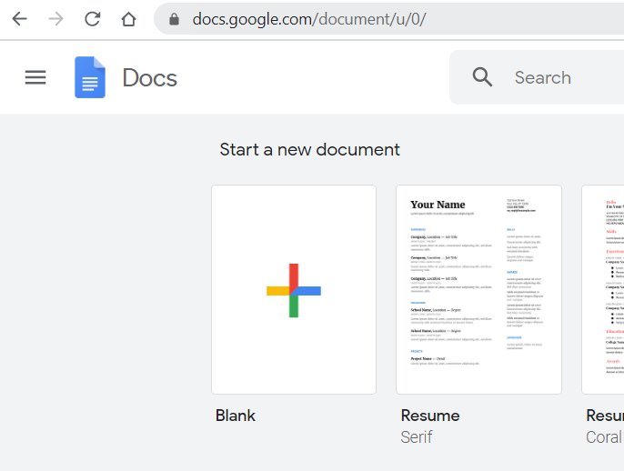

Choose to “Start a new document” -> “Blank”.

Edit the title of the document to be your “Student ID – Your Name – Course Code” :-

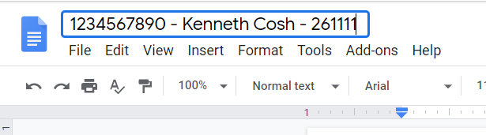

Choose “File -> Share”

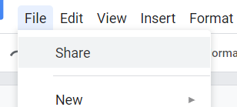

Select Advanced, and check both the options in “Owner settings” and save your changes.

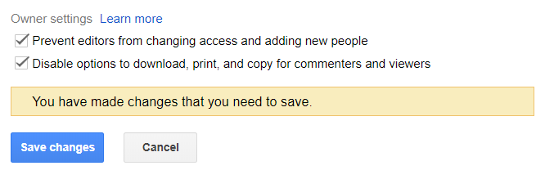

Next, Invite Me to your document using my email address “drkencosh@gmail.com”

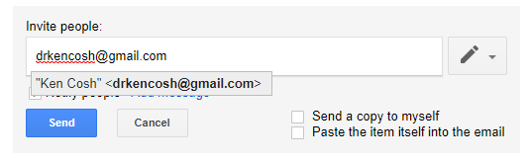

You should see that we both have access to the document. Next you need to **make me to the owner** of the document – Click on the pencil next to my name and change from ‘Can edit’ to ‘Is owner’ (the top option – possibly “เป็นเจ้าของ”).

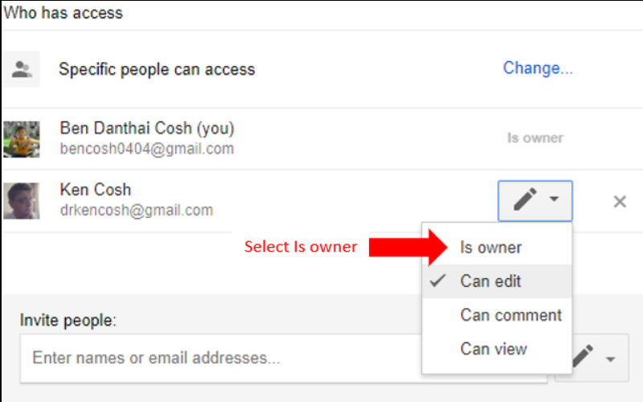

If your setup is in Thai by default you may need to set me to be “เป็นเจ้าของ”

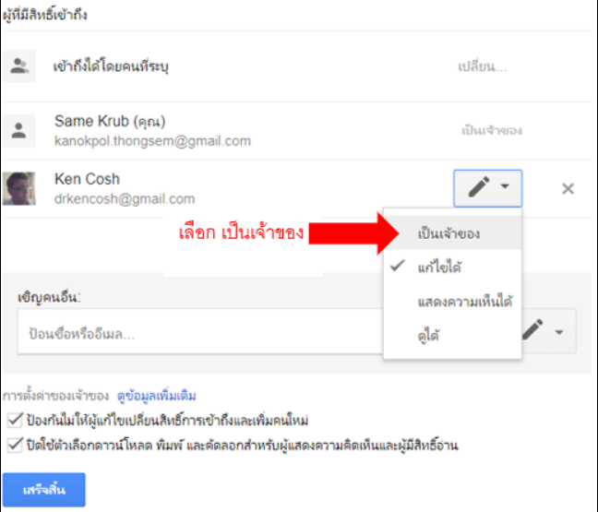

You will be asked “Are you sure?” – Yes you are! Click Yes, and then you can click “Done”.

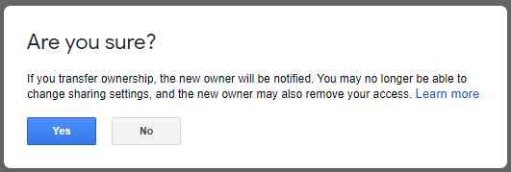

Make sure you know where this document is for the final exam as you will need it to write your answers.