**Microsoft Access – Quick Tutorial!**

Access is part of the office suite, and gives us a way of creating databases on the desktop – we’ll use it to create a simple database to record student grades in various courses. For this we will need 3 tables – a table to store courses, a table to store student information and a table to store the grades.

Let’s start with the student table – what information do you need to store about each student? FirstName? LastName? Email? DoB? Open up Microsoft Access, and create a new blank desktop database. You will then be able to create the student table. The ID field is created by default, so by clicking on the next columns you can add the other fields you need, also selecting the type of data to be stored.

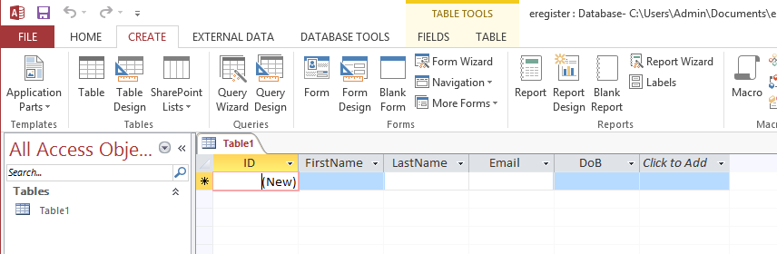

Save this table (as Student). The next step will be to create a form to allow a user to input the student’s details. Select ‘Create’ and ‘Form’, and a default form will be created for you. By using the buttons in the bottom right corner, you can switch between different views of the form, and use the ‘Design View’ to make your form look nicer! You will probably want to remove the ‘ID’ field!



Save the form, and then you can create some sample data using the ‘Form View’. You can check that the data is now in the table by going back to the table and selecting ‘Refresh All’ from the Home Menu.

Great! You should now have a form for storing student information, and some sample data. Go through the same process to create a new table for Course data – what fields are needed? CourseCode? CourseName? Credits? Create some sample data again.

As mentioned before, where databases get more useful is by being able to link data - here we want to link students with courses, and store their grades. Create the third table with the columns; Course, Student and Grade. This time when you choose the type for the fields ‘Course’ and ‘Student’, select ‘Lookup & Relationship’, and work through the simple lookup wizard to select how the user will choose the course / student information. Grade should be a simple number type. You can check that you have successfully added the “Foreign Keys” by choosing ‘Table Tools’ and ‘Relationships’ and you should get a graphic similar to the one below.

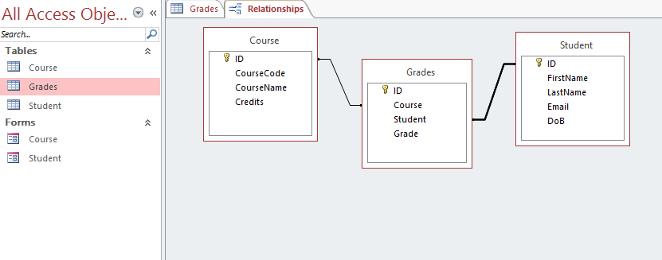

By now you should have 3 tables and 2 forms, so next up we need to create the form for the Grades table – the same as we did above, but notice this time you get a drop down box allowing you to choose which course and which student. Create some dummy data again.

**Queries & Reports**

Having successfully got data into the database, the next step is to build queries and get data back out of the database – the right data! The first step here is to build a query, so let’s suppose we want to generate a report of the grades for a particular course – choose ‘Create’ and ‘Query Design’, and when prompted add all 3 tables – you will again be shown the relationships between the tables as above. Select which fields you want involved in the query, by double clicking on them – they will then appear in the table below. For this we will need the course code from the Course Table, the FirstName and LastName from the Student table and the Grade from the Grades table.

For this query we only want to get results for a particular course, so add the course code you are interested in to the ‘Criteria’ Field – as shown in the screen dump below.

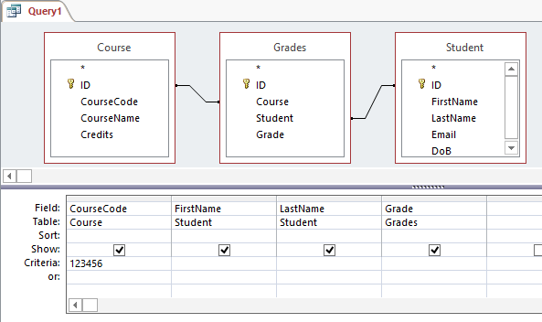

Now you have your query you can save it, and run it – you should be presented with the results you want!

Next up, let’s build a report of the results generated from the query. Use the Report Wizard to help you choose the query information – and be sure to add summary data!

**Exercise**

|  |  |
| --- | --- |
| code | Extend your E-Registration program to create a report for each student’s grades! |